# Lab 23 Redux: Installation & Configuration

## Objectives

*  Install Redux and related packages
*  Configure Redux

## Steps

### Install Redux

1. **Open** a command prompt (Windows) or terminal (Mac).
2. Change the **current directory** to working\keeptrack.
3. Run the following command:

#### npm

npm install redux react-redux redux-devtools-extension redux-thunk

1. After the installs finish, open the \package.json file and quickly verify the packages were added to the dependencies and devDependencies.

### Configure Redux

1. Create the following file and configure Redux.

#### src\state.js

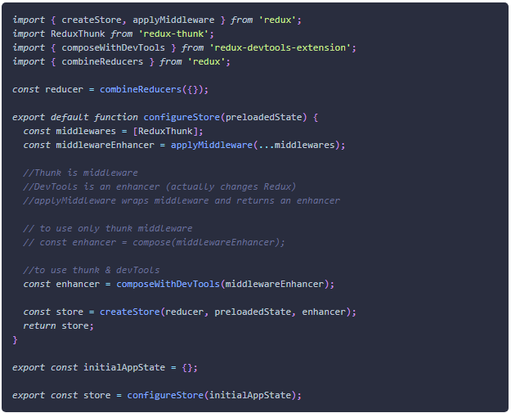

1. **Verify** the application **compiles**.

### ✔ You have completed Lab 23